MS SQL
Posted Aug 20, 2003

Migrating a Maintenance Plan from One SQL Server to Another
By Gregory A. Larsen
Have you ever had to migrate all of the SQL Server objects from one machine to another SQL Server box? If you have, you probably have found that Microsoft has not provided a method to build a migration script for a maintenance plan. Since there is no easy way to migrate a maintenance plan, most DBAs just recreate all their maintenance plans on the new SQL Server machine. In this article I will show you a method to migrate a maintenance plan from one SQL Server machine to another.
The process I have developed for migrating a maintenance plan is not a simple point and click method. There are a number of steps, both automated and manual, to perform the migration of a maintenance plan. I will walk you through each step. Keep in mind that these steps outline only how to migrate a single maintenance plan. If you want to migrate multiple migration plans then you will need to run through these steps multiple times.

Step 1 - Determine Maintenance Plans on Source Server
This step will determine the maintenance plans that are on the source SQL Server machine. SQL Server has provided the sp_help_maintenance_plan stored procedure (SP) which will display a single maintenance plan or all of the maintenance plans. The syntax for calling this SP is:
sp_help_maintenance_plan [ [ @plan_id = ] 'plan_id' ]
If you specify a plan_id then only that plan will be displayed. If no plan_id is passed then this SP will return all maintenance plans.
Remember maintenance plans are stored in the msdb database. This SP is also stored in the msdb database. To display all the maintenance plans on a server you would execute the following command:
exec msdb.dbo.sp_help_maintenance_plan
This command returns output that displays the plan_id, plan name, and a few other columns. On my server the following is displayed:
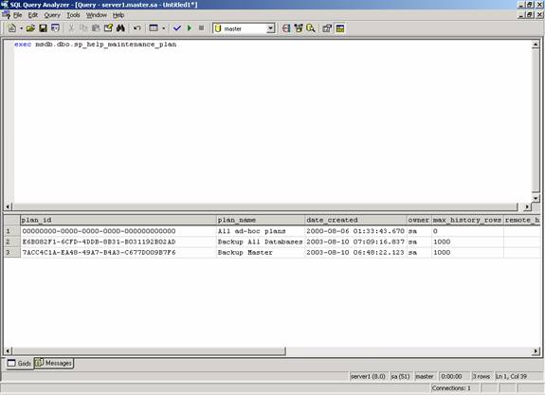
From this output you can see that I have two maintenance plans. One called "Backup All Databases" and another called "Backup Master." The "All ad-hoc plans" is a system generated plan, that SQL Server generated, note the plan_id.

Step 2 - Determine SQL Server Agent Job Id for Specific Maintenance Plan
From the output displayed by executing the sp_help_maintenance_plan you can determine the plan_id's for each plan on your source SQL Server machine. Next I need to determine which plan_id I wish to migrate, then issue the following SP replacing <plan_id> with the plan I am going to migrate:
exec msdb.dbo.sp_help_maintenance_plan '<plan_id>'
This command will identify the databases that are referenced in the maintenance plan and the job_id assigned to SQL Server agent Job associated with the plan_id.
From my server I have chosen to display the information associated with the "Backup All Databases" maintenance plan, therefore I would execute the following command:
exec msdb.dbo.sp_help_maintenance_plan 'E6B082F1-6CFD-4DDB-8B31-B031192B02AD'
When I execute the above command I get the following output:
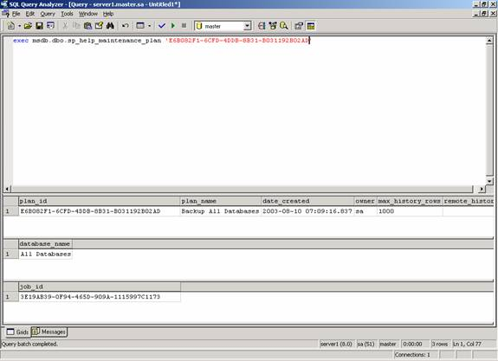

Step 3 - Determine Name of SQL Server Agent Job
From the output generated in step 2, we can see for maintenance plan_id ' E6B082F1-6CFD-4DDB-8B31-B031192B02AD' the SQL Server Agent job associated with this plan has a job_id of '3E19AB39-0F94-465D-909A-1115997C1173'. Passing this job_id to the 'sp_help_job' SP I can determine which SQL Agent job name is associated with this maintenance_plan (plan_id).
When I execute following code:
exec msdb.dbo.sp_help_job '3E19AB39-0F94-465D-909A-1115997C1173'
I get the following output:
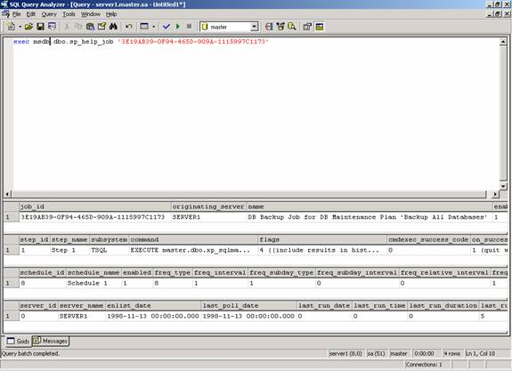
From this output you can see that the job name is 'DB Backup Job for DB Maintenance Plan 'Backup All Databases''.

Step 4 - Generate T-SQL Script for SQL Server Agent Job on Source Server
Now that I have the name of the SQL Server Agent job I can generate a T-SQL script to create the job on the target server. To generate the script I normally use the "Generate SQL Script ..." function that is available when right clicking on the job in Enterprise Manager, select the "All Tasks" option, then I save the generated script to a file to be used in the next step.

Step 5 - Create SQL Server Agent Job on Target Server
Using the script I generated in step 4, I can create the 'DB Backup Job for DB Maintenance Plan 'Backup All Databases'' on the Target Server. To do this, I put the script saved in Step 4 onto a floppy, load the script on my target server, and then execute the script in Query Analyzer. This will create my maintenance plan database backup job on the target server.

Step 6 - Create the Maintenance Plan on Target Server
To create the maintenance plan on the Target Server I use the sp_add_maintenance_plan SP. I do this by using the following simple script:
declare @myplan_id uniqueidentifier
exec msdb.dbo.sp_add_maintenance_plan N'Backup All Databases',@plan_id=@myplan_id output
print @myplan_id
Note I printed the plan_id that was created. This will be needed in the next step. The maintenance plan_id I created was "E219D922-9B4F-4C15-BC16-35E0C93CB3EA".

Step 7 - Add databases to Maintenance Plan
In this step I will be modifying the maintenance plan I created in Step 6. I will be adding each database on my Target Server to the maintenance plan by using the sp_add_maintenance_plan_db SP. Each database will need to be added separately since there is no "All Database" option for this SP. A series of calls to this SP will be needed to add each database. Below is a sample of the commands that would be necessary to add each of the standard SQL Server databases to my target server maintenance plan.
exec msdb.dbo.sp_add_maintenance_plan_db 'E219D922-9B4F-4C15-BC16-35E0C93CB3EA',N'master'
exec msdb.dbo.sp_add_maintenance_plan_db 'E219D922-9B4F-4C15-BC16-35E0C93CB3EA',N'model'
exec msdb.dbo.sp_add_maintenance_plan_db 'E219D922-9B4F-4C15-BC16-35E0C93CB3EA',N'msdb'
exec msdb.dbo.sp_add_maintenance_plan_db 'E219D922-9B4F-4C15-BC16-35E0C93CB3EA',N'pubs'

Step 8 - Add SQL Agent Job to Maintenance Plan
Basically at this point I have the SQL Server Agent job 'DB Backup Job for DB Maintenance Plan 'Backup All Databases'' and the maintenance plan 'Backup All Databases' created on the target server, all that is left to do is associate the SQL Server Agent job with the Maintenance Plan. To do this I will need to execute the 'sp_add_mainetenance_plan_job' sp. This sp has the following format:
sp_add_maintenance_plan_job 'plan_id' , 'job_id'
Now from step 6 we already know the 'plan_id', but we don't know the 'job_id' associated with the 'DB Backup Job for DB Maintenance Plan 'Backup All Databases' SQL server agent job. To get the job_id, for this job we need to execute the 'sp_help_job' SP, like so:
exec msdb.dbo.sp_help_job
@job_name='DB Backup Job for DB Maintenance Plan ''Backup All Databases'''
From the output generated when I executed the sp_help_job SP I find that the job_id is '81160E1C-9AA8-4104-9A0A-5463534C08EC'. So at this point all that is left to associate my job with my maintenance plan is to execute the following command:
exec msdb.dbo.sp_add_maintenance_plan_job
'E219D922-9B4F-4C15-BC16-35E0C93CB3EA',
'81160E1C-9AA8-4104-9A0A-5463534C08EC'

Conclusion
These are all the steps it takes to migrate a single maintenance plan from a source server to a new target server. Ok, now I never said it was going to be easy. In reality if you only need to migrate a single maintenance plan then it might be just as easy to rebuild the maintenance plan on the new server. Although if you are planning on migrating a fair number of maintenance plans then building a process to migrate each maintenance plan using the steps I identified above might a much easier then building each maintenance plan on the new server manually.

