FactoryLink server | DMV  Fl-Servers T01C1
WCONFIG.DBF voor schermplaatsing bij opstart FactoryLink


RLD  Automation | v. Sonsbeeckstraat 11  5344 JB Oss  Tel: 0412-655909  Mail: mjordaan@rldautomation.eu | Opdrachtgever:  Project:  Project id: | DMV  FL-Servers T01C1  V109022
Industriële Automatisering |  | 

Inhoudsopgave

1 WCONFIG.CDB 3
1.1 Inleiding 3

WCONFIG.DBF

Inleiding
De dBase IV database tabel wconfig is aanwezig in de map net van de FactoryLink appplicatie. In deze table is de configuratie van beeldschermen, en positionering van vensters opgenomen voor iedere server en webclient. De tabel wordt op basis van PC-naam door iedere grafische client uitgelezen, de informatie in de table bestaat uit het aantal aanweizge monitoren per client, positionering van mde maximaal 4 vensters voor de applicatie, en de ‘start’ schermen in de vensters.

Als een client bij opstart geen congiratie record in de wconfig.cdb kan vinden dan wordt verondersteld dat er 4 vensters geopend dienen te worden, in ieder venster wordt het scherm start getoond, zie onderstaande afbeelding.

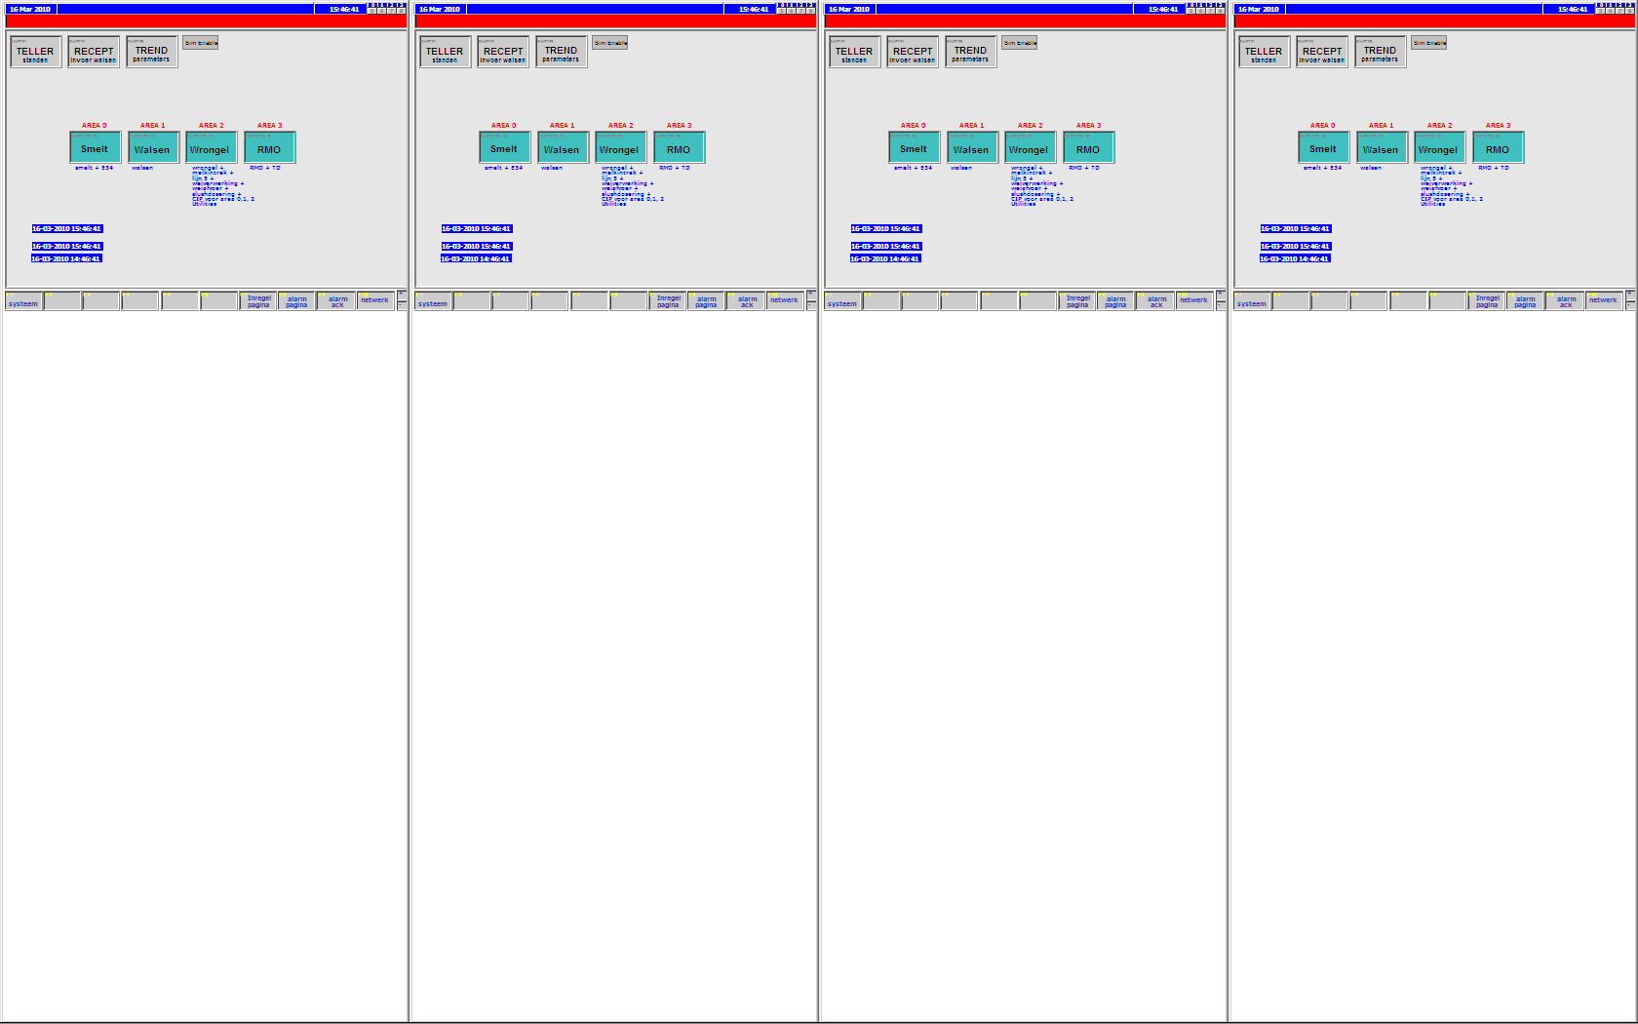

Tabel wconfig.dbf
De tabel is als volgt gedefinieerd, achter de laatse kolom is een omschrijving opgenomen. Iedere regel is in de database tabel een veld in een rij, de tabel is hier gespiegeld weergegeven en alleen de configuratie voor beide servers is opgenomen.

PC | FL_EIWIT_S1 | FL_EIWIT_S2
MONITOR | 1 | 1 | Gereserveerd, momenteel niet in gebruik.
SCREEN | 1 | 1 | Aantal vensters te openen bij start (web)client.
XPOS1 | 256 | 0 | X positie venster 1 (linksboven: x=0, y-0).
XPOS2 | 0 | 380 | X positie venster 2 (linksboven: x=0, y-0).
XPOS3 | 0 | 0 | X positie venster 3 (linksboven: x=0, y-0).
XPOS4 | 0 | 0 | X positie venster 4 (linksboven: x=0, y-0).
YPOS1 | 0 | 0 | Y positie venster 1 (linksboven: x=0, y-0).
YPOS2 | 0 | 0 | Y positie venster 2 (linksboven: x=0, y-0).
YPOS3 | 0 | 0 | Y positie venster 3 (linksboven: x=0, y-0).
YPOS4 | 0 | 0 | Y positie venster 4 (linksboven: x=0, y-0).
SIZE1 | 768 | 768 | Hoogte venster 1 in pixels.
SIZE2 | 0 | 640 | Hoogte venster 2 in pixels.
SIZE3 | 0 | 0 | Hoogte venster 3 in pixels.
SIZE4 | 0 | 0 | Hoogte venster 4 in pixels.
WIDTH1 | 1024 | 1024 | Breedte venster 1 in pixels.
WIDTH2 | 0 | 480 | Breedte venster 2 in pixels.
WIDTH3 | 0 | 0 | Breedte venster 3 in pixels.
WIDTH4 | 0 | 0 | Breedte venster 4 in pixels.
START1 | start | start | Naam van plaatje dat als eerste in venster 1 getoond wordt.
START2 |  | afzak | Naam van plaatje dat als eerste in venster 2 getoond wordt.
START3 |  |  | Naam van plaatje dat als eerste in venster 3 getoond wordt.
START4 |  |  | Naam van plaatje dat als eerste in venster 4 getoond wordt.

Een eenvoudige manier om een dBASE IV tabel te bewerken is gebruik te maken van win32dbf.exe, dit is een freeware programma om dBASE tabellen met te bewerken (http://www.buchenwald.de/software/windbf-e.html).

WinDBF32 Database Editor
WinDBF32 is a database program that can handle dBase, FoxPro and HiPer-Six files.
Allows the use of native dBase (xBase) field types: character, numeric, logical, date, memo and blob.
Features:
- Form designer
- Report designer
- Table designer
- Advanced FTS search and xBase query builder.
- Index orders generate, select and search use.
- Export & import (includes export to CSF and XLS files).
- OEM Char Translate convert between DOS and Windows ANSI charset.
- Blob Support easily add and view images.
- Keyboard and Mouse navigation.
- Master Slave Support with INI-Files.
- Automatic Backup System.
Command line:
WinDBF32 accepts a database filename as the first command line parameter. This file will be loaded when WinDBF32 is run. With the second parameter start query optinonal.
Associate the dbf file:
WinDBF32 associate the dbf file extension with WinDBF32 as your default dbf program. When you then double-click a dbf file in Windows Explorer, WinDBF32 will be launched and the selected dbf file will be loaded.
Automatic form loading:
Each time you open a dbf file, WinDBF checks if there is a form with the same base name in the same directory and will load that form when available.
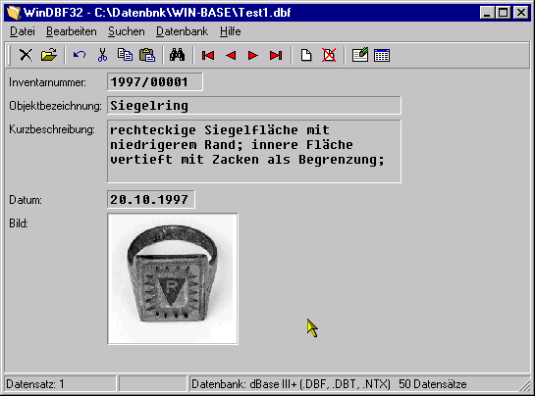

Bijwerken van de configuratie met windbf32 ziet er als volgt uit:

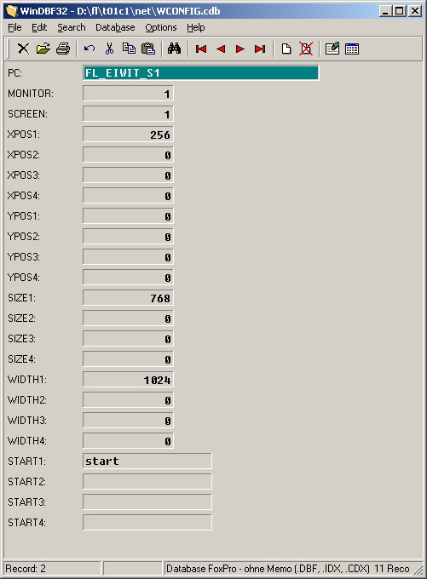

Ophalen gegevens WCONFIG tabel
Met de dBase IV Historian en DBBROWSE worden de gegevens uit de wconfig tabel gehaald.

Historian Information for dBASE IV(R)

Domain Name : SHARED

_______________________________________________________________________________
Database Alias Name : FLAPP
Disable/Enable Connection:
*Database Directory : '{FLAPP}/net
Connection Status :
Database Error :

Database Browser Control

Domain Name : USER

_______________________________________________________________________________
Browse Name : WCONFIG
Select Trigger : read_screen
Update Trigger :
Delete Trigger :
Move Trigger :
Position Trigger :
Historian Mailbox : db4_mbx
Database.Table Name : FLAPP.WCONFIG
Current Row Tag :
Auto Create Record? : NO
Browse Table Size (Rows) : 1
Internal Buffer Size (Rows): 1
External Buffer Size (Rows):
Disable Tag :
Completion Trigger : read_screen_compl
Completion Status : read_screen_status

Database Browser Information

Domain Name : USER
Table Name : WCONFIG

_______________________________________________________________________________
Tag Name : INI_PCNAME
Logical Operator :
Column Name : PC
Logical Expression: =:MYPCNAME
_______________________________________________________________________________
Tag Name : INI_MONITOR
Logical Operator :
Column Name : MONITOR
Logical Expression:
_______________________________________________________________________________
Tag Name : INI_SCREEN
Logical Operator :
Column Name : SCREEN
Logical Expression:
_______________________________________________________________________________
Tag Name : INI_START[1]
Logical Operator :
Column Name : START1
Logical Expression:
_______________________________________________________________________________
Tag Name : INI_START[2]
Logical Operator :
Column Name : START2
Logical Expression:
_______________________________________________________________________________
Tag Name : INI_START[3]
Logical Operator :
Column Name : START3
Logical Expression:
_______________________________________________________________________________
Tag Name : INI_START[4]
Logical Operator :
Column Name : START4
Logical Expression:
_______________________________________________________________________________
Tag Name : INI_XPOS[1]
Logical Operator :
Column Name : XPOS1
Logical Expression:
_______________________________________________________________________________
Tag Name : INI_XPOS[2]
Logical Operator :
Column Name : XPOS2
Logical Expression:
_______________________________________________________________________________
Tag Name : INI_XPOS[3]
Logical Operator :
Column Name : XPOS3
Logical Expression:
_______________________________________________________________________________
Tag Name : INI_XPOS[4]
Logical Operator :
Column Name : XPOS4
Logical Expression:
_______________________________________________________________________________
Tag Name : INI_YPOS[1]
Logical Operator :
Column Name : YPOS1
Logical Expression:
_______________________________________________________________________________
Tag Name : INI_YPOS[2]
Logical Operator :
Column Name : YPOS2
Logical Expression:
_______________________________________________________________________________
Tag Name : INI_YPOS[3]
Logical Operator :
Column Name : YPOS3
Logical Expression:
_______________________________________________________________________________
Tag Name : INI_YPOS[4]
Logical Operator :
Column Name : YPOS4
Logical Expression:
_______________________________________________________________________________
Tag Name : INI_SIZE[1]
Logical Operator :
Column Name : SIZE1
Logical Expression:
_______________________________________________________________________________
Tag Name : INI_SIZE[2]
Logical Operator :
Column Name : WIDTH2
Logical Expression:
_______________________________________________________________________________
Tag Name : INI_SIZE[3]
Logical Operator :
Column Name : WIDTH3
Logical Expression:
_______________________________________________________________________________
Tag Name : INI_SIZE[4]
Logical Operator :
Column Name : WIDTH4
Logical Expression:
_______________________________________________________________________________
Tag Name : INI_WIDTH[1]
Logical Operator :
Column Name : WIDTH1
Logical Expression:
_______________________________________________________________________________
Tag Name : INI_WIDTH[2]
Logical Operator :
Column Name : SIZE2
Logical Expression:
_______________________________________________________________________________
Tag Name : INI_WIDTH[3]
Logical Operator :
Column Name : SIZE3
Logical Expression:
_______________________________________________________________________________
Tag Name : INI_WIDTH[4]
Logical Operator :
Column Name : SIZE4
Logical Expression:

Graphics configuration
Voor de graphics configuration dient het voglende gerealiseerd te worden:
- Start scherm wordt ‘SPLASH’
- Openen van SPLAH scherm zorgt voor start van laden scherm gegevens uit wconfig, de PC naam wordt vanaf de tag FLHOST gelezen, en gebruikt voor een SQL select statement.
- Na inlezen van de gegevens worden de instellingen in PVB code verwekrt en worden de gewneste plaatjes en groottes ingesteld.
- Instellen van de schermgrootes wordt gedaan door een exe-bestand ‘flmove.exe’, dit is een gecompileerd AutoIt script.

Kern van de PVB routine die zorgt voor de scherminstellingen zier er als volgt uit.
1 ' Continue after 5 second delay
2 Private Count
3 Private ReadDB as integer
4
5
6 sub mymove( wname as string, xpos as integer, ypos as integer, wheight as integer, wsize as integer)
7 dim sdo as string
8 dim id as integer
9 if (wsize > 0) and (wheight > 0) then
10
11 sdo = "/net/flmove " & wname & " " & xpos & " " & ypos & " " & wsize & " " & wheight
12 else
13
14 sdo = "/net/flmove " & wname & " " & xpos & " " & ypos
15 end if
16
17 id = shell( environ("FLAPP") & sdo, 7)
18 end sub
19
20
21 sub splash_g1018_Delay
22 dim i as integer
23 dim stat as integer
24
25
26 THIS.text = Count
27 Count = Count + 1
28
29 ReadDB = read_screen_compl.value
30 stat = read_screen_status.value
31
32 if (Count > 10) then
33
34 INI_START(1).value = "START"
35 INI_START(2).value = "START"
36 INI_START(3).value = "START"
37 INI_START(4).value = "START"
38 INI_SCREEN.value = 4
39 INI_MONITOR.value = 4
40
41 SCR1_DRW.value = INI_START(1)
42 SCR2_DRW.value = INI_START(2)
43 SCR3_DRW.value = INI_START(3)
44 SCR4_DRW.value = INI_START(4)
45
46 enb_s1.force 1
47 enb_s2.force 1
48 enb_s3.force 1
49 enb_s4.force 1
50 Count = 0
51 SPLASH_ENA = 0
52 end if
53
54 if (ReadDB) and (stat = 0) then
55
56 'enable alleen het aantal opgegeven windows
57 For i = 1 to INI_SCREEN
58
59 if i = 1 then
60 if ReadDB then
61 mymove "SCR_1", INI_XPOS(i), INI_YPOS(i), INI_SIZE(i), INI_WIDTH(i)
62 end if
63 enb_s1.force 1
64 end if
65 if i = 2 then
66 if ReadDB then
67 mymove "SCR_2", INI_XPOS(i), INI_YPOS(i), INI_SIZE(i), INI_WIDTH(i)
68 end if
69 enb_s2.force 1
70 end if
71 if i = 3 then
72 if ReadDB then
73 mymove "SCR_3", INI_XPOS(i), INI_YPOS(i), INI_SIZE(i), INI_WIDTH(i)
74 end if
75 enb_s3.force 1
76 end if
77 if i = 4 then
78 if ReadDB then
79 mymove "SCR_4", INI_XPOS(i), INI_YPOS(i), INI_SIZE(i), INI_WIDTH(i)
80 end if
81 enb_s4.force 1
82 end if
83 Next i
84
85 SCR1_DRW.value = INI_START(1)
86 SCR2_DRW.value = INI_START(2)
87 SCR3_DRW.value = INI_START(3)
88 SCR4_DRW.value = INI_START(4)
89 Count = 0
90 SPLASH_ENA = 0
91 end if
92 end sub
93
94
95
96 sub splash_g1018_DrawLoad
97
98 This.Left = -32000 ' hide object
99
100
101 'start browser actie voor lexen window info
102 ReadDB = 0
103 MYPCNAME.value = environ("COMPUTERNAME")
104 LockRTDB
105 read_screen_compl.value = 0
106 read_screen.force 1
107 UnLockRTDB
108 end sub
109
110
111 sub splash_g1018_Config
112
113 ReadDB = 1
114 end sub

AutoIt script:
;
; AutoIt Version: 3.0
; Language: English
; Platform: WinXP/2003/Vista
; Author: Marcel Jordaan (mjordaan@rldautomation.eu)
;
; Script Function:
; Move and resize a window by it's title
; Usage:
; Calling this script in cmd or batch file makes it possible to move a window by its title
; flmove "title" "xpos" ypos" "width" "height".
;initialize the command line parameter string
dim $params[10]
;Get the commandline and build the parameter list for webclient
For $i = 1 to $CmdLine[0] step 1
If $i < 6 Then
$params[$i] = $CmdLine[$i]
EndIf
Next
If $CmdLine[0] < 5 Then
winmove( $params[1], "", $params[2], $params[3])
Else
winmove( $params[1], "", $params[2], $params[3], $params[4], $params[5])
EndIf
; Finished!
-

