How to "Multithread" an Arduino (Protothreading Tutorial) © GPL3+
Arduino's great, but how in the world do you do two (or more) things at once on separate intervals? You need protothreading!
- protothreading
- multithreading
- arduino
- 22,164 views
- 20 comments
- 56 respects

Components and supplies
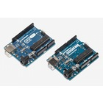 |  | × | 1
  Arduino UNO & Genuino UNO
 |  | × | 1
  Sunfounder Blue 16x2 Liquid Crystal Display (LCD)
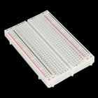 |  | × | 1
  Breadboard (generic)
  and wires of course.
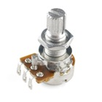 |  | × | 1
  Rotary potentiometer (generic)
  Not sure of resistance rating, probably 1Kohm would do.

About this project

Let's start with a video and a question.
This video depicts something you may have wanted to do during your budding prototyping career, coaxing a single-core arduino to do 3 things at once. In this case, we're:
- Pulsing the backlight at a constant rate without interruption
- Incrementing an integer every second and writing it to the display without interruption
- Rotating a few messages every few seconds and writing them to the display without interruption
caption (optional)

You saw the title.
You can use Protothreading to do two (or more) things at different intervals on an Arduino. In other words, it's "multithreaded"! But hold on there Sparky, the Arduino is a single-core chip with procedural code, so true multithreading is impossible. Why though? How is protothreading any different?

"Real" Multithreading vs Protothreading
To understand protothreading properly, we first need to understand why it's NOT really multithreading.
Remember back in the day when Intel was selling us "Hyperthreading" on these new Pentium processors? No? You weren't born yet? Well time for a history lesson then, son. "Hyperthreading" was a technology Intel employed to make a single core on a processor "act" like it was two cores, or two cores "act" like they're 4 cores, etc. But why does any of this matter? The answer is cycles.
CPUs do work in "cycles". How fast they do them (how many in a second) is the clock rate. You've seen a CPU's computers "Ghz" rating relate to how fast it is. The more Ghz, the better, right? Why? Because that's the number of cycles per second a processor can achieve (without overheating and catching on fire - really!).
If you're a datasheet nerd, you might know that the Arduino Uno's microprocessor chip, the Atmel ATMega328P, runs at 16Mhz out of the box. It's capable of 20Mhz, but is dialed back so it won't mess up things like writing data to memory, or, you know, catch fire. 16Mhz means every second, your Arduino is processing 16,000,000 cycles, or pieces of work. Now, these are NOT lines of code - that'd be blazingly fast and Arduino is relatively slow. These are processor instructions such as moving data in and out of registers. It all gets very technical, so you can read up on that independantly if you want.
If we can only go so fast on a core before the best chip available catches fire, are we stuck at that speed? As it turns out, no! Enter multicore CPUs, and multithreading. Multithreaded applications run two separate processes that work in parallel to one another on different cores of a CPU. These processes interact to get work done together, but do not "split the work evenly" as you might assume. There is typically a main process / "thread" that functions as a manager of the other threads, and then one or more worker threads it manages, which each might do specific tasks. This is the first reason Protothreading is not multithreading - we only have one core to work with so it's straight up impossible.

Ok, how is Protothreading different then?
Protothreading is very simillar to that Hyperthreading thing I mentioned, to an extent. Hyperthreading would emulate a second core and literally divide the work between the two "cores". This worked because they really existed on the same core and thus shared the same resource space. That is NOT what we're doing here. Protothreading is similar, except that we break down execution of our application by loop instead of by CPU instructions (which you would normally never see). There are different implementations of it, and the one I use here is admittedly probably shoddy, but it works. Basically, each loop we're not doing work, we're checking to see if it's time to do a particular piece of work. If so, we do it. It's important to note that actions that are blocking and are not loops, such as reading data, will still block other protothreads, but for simple things like two loops going at once performing quick variable changes, it will work superbly. This is what we'll be doing.
We first figure out what tasks we need to perform. In my case, I picked (a) fade the backlight of my LCD panel in and out for a neat "pulsing" effect, while (b) counting up a number on a much slower, (and possibly non-divisible) interval, and (c) rotating some string messages at a yet much slower interval. Some guidelines to follow to make sure this process works smoothly are to rate your functions from the least-blocking to the most-blocking. Actions (let's call them "functions" from this point on) that take longer, like reading data or have other long delays, and functions with larger intervals between when they fire are the most-blocking functions. Functions which fire very frequently, if not every loop, and don't take long to complete are the least-blocking functions. The very least blocking function is what you should use as your primary "thread". Can you guess which it is above?
That's right, it's "a", pulsing the backlight in and out. This will be at a regular and very fast interval, perpetual with no delays inbetween fires other than getting the work done, and the work itself is very fast. The perfect manager thread.
We will use this thread (and any loops within it) to check if the other threads need to do any work. It's probably best to read through the code at this point - it is heavily documented. See the main loop toward the bottom. You can see me checking if threads need any work where I call numberThread.check() and textThread.check().
I need to do this within any loops in the main thread as well, as they will block until completion if I don't. I set the interval at which the threads need to fire when I initialize them during init or the setup portion of the code. If it's time for these threads to fire, .check() will see that and perform their work before continuing the main thread.
That's really it in a nutshell, the rest of it you can probably figure out yourself by looking at the code. Let me end by saying while I may sound like it, I'm NOT a protothreading pro by any means, this is just a simple example I hacked up. If you have any tips or if I was wrong about anything, I encourage feedback and corrections! Thanks :)

Schematics

Circuit Diagram
This may vary slightly depending on your LCD model. Compare the markings on the pin letters, as well as the pin numbers in the code's comments to ensure things are wired up right. I pulled this diagram from elsewhere, but I will ensure it's right soon.
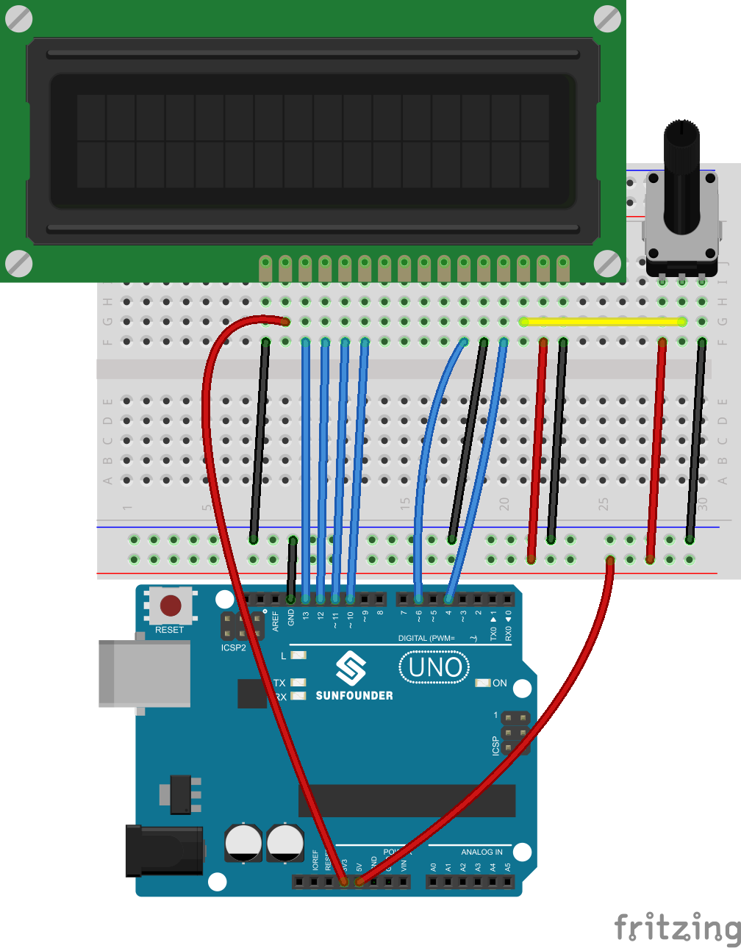

Code

Multithreaded LCD Code - multithread.inoArduino
This bit of code uses the <TimedAction.h> library to perform 3 repeating actions with separate intervals at the same time on one Arduino Uno processor. It will (a) Fade the backlight in and out, while (b) incrementing a number, and (c) rotating between a few strings of text. See the video above for a demo :)

