SQL Server: How to Check if a File Exists in a Directory
Posted September 20, 2012 by Vishwanath Dalvi in Database, SQL Server
Frequently, when working with SQL, we need to know if a file exists in a local directory or not. This can be done using SQL Server’s built-in procedure known as master.dbo.xp_fileexist. This user-defined function (UDF) checks whether or not a file exists in a specified directory.
create FUNCTION dbo.fc_FileExists(@path varchar(8000))
RETURNS BIT
AS
BEGIN
DECLARE @result INT
EXEC master.dbo.xp_fileexist @path, @result OUTPUT
RETURN cast(@result as bit)
END;
GO
In the function above, we are passing parameter @path, and the built-in procedure master.dbo.xp_fileexist will check whether that file really exists on the specified path. The function will return 1 if it exists. If the file does not exist, the function will return 0.
Let us see how this function performs with an example.
select dbo.fc_FileExists('C:\mywork\tech-recipes.rar');
-----
1

select dbo.fc_FileExists('C:\mywork\barfi.mp3');
-----
0
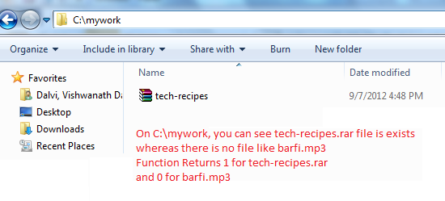
If you’ve a table with a column listing all the file paths you can use this function on table too.
Create table filelist
(
fileno int,
filename varchar(max)
);
Let us insert sample data.
Insert into filelist values (1, 'C:\mywork\tech-recipes.rar');
Insert into filelist VALUES (2, 'C:\mywork\barfi.mp3');
Here we can use the dbo.fc_FileExists(filename) function to check whether or not the file exists.
Select fileno,
filename,
dbo.fc_FileExists(filename) as IsFileExists
From filelist;

fileno filename IsFileExists
----------- ------------------------------------ ------------
1 C:\mywork\tech-recipes.rar 1
2 C:\mywork\barfi.mp3 0

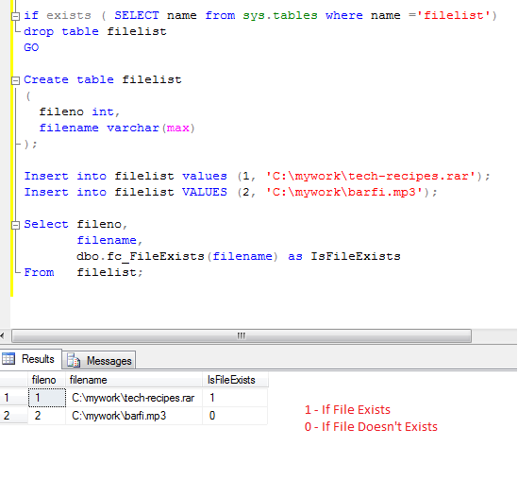
IsFileExists is a temporary column. If you want to make it a permanent column, you will need to use update query.

CREATE TABLE #TEXTFILE_1(
FIELD1 varchar(100) ,
FIELD2 varchar(100) ,
FIELD3 varchar(100) ,
FIELD4 varchar(100));

BULK INSERT #TEXTFILE_1 FROM 'C:\STUFF.TXT'
WITH (FIELDTERMINATOR =',',ROWTERMINATOR ='\n')

/*You now have your bulk data*/

insert into yourtable (field1, field2, field3, field4, field5, field6)
select txt.FIELD1, txt.FIELD2, txt.FIELD3, txt.FIELD4, 'something else1', 'something else2'
from #TEXTFILE_1 txt

drop table #TEXTFILE_1

Inlezen mpv file, met werkend try catch gedeelte.
IF OBJECT_ID('tempdb..#TEXTFILE_1') IS NOT NULL
DROP TABLE #TEXTFILE_1;

CREATE TABLE #TEXTFILE_1(
FIELD1 varchar(100) ,
FIELD2 varchar(100) ,
FIELD3 varchar(100) ,
FIELD4 varchar(100) ,
FIELD5 varchar(100) ,
FIELD6 varchar(100) ,
FIELD7 varchar(100));

--BULK INSERT #TEXTFILE_1 FROM 'd:\ftp\mpv\ftps2.TXT'
--WITH (FIELDTERMINATOR =',',ROWTERMINATOR ='\r\n');

--BULK INSERT #TEXTFILE_1 FROM 'd:\ftp\mpv\Ftps4.txt' WITH (FIELDTERMINATOR = ',',ROWTERMINATOR ='\n');
/*You now have your bulk data*/
begin try
DECLARE @cmd varchar(1000)
SET @cmd = 'BULK INSERT #TEXTFILE_1 FROM ''d:\ftp\mpv\ftps4.TXT''
WITH (FIELDTERMINATOR = '','',ROWTERMINATOR =''\n'')';
EXECUTE (@cmd);
end try
begin catch
PRINT 'Bulk insert failed, no data, stop processing\n';
drop table #TEXTFILE_1;
return;
end catch
--insert into yourtable (field1, field2, field3, field4, field5, field6, field7)
select txt.FIELD1, txt.FIELD2, txt.FIELD3, txt.FIELD4, txt.FIELD5, txt.FIELD6, txt.FIELD7
--select *
from #TEXTFILE_1 as txt;

drop table #TEXTFILE_1;

-- To allow advanced options to be changed.
EXEC sp_configure 'show advanced options', 1
GO
-- To update the currently configured value for advanced options.
RECONFIGURE
GO
-- To enable the feature.
EXEC sp_configure 'xp_cmdshell', 1
GO
-- To update the currently configured value for this feature.
RECONFIGURE
GO

DECLARE @PathName VARCHAR(256)='\\massas1\mpv\ftps?.txt', --path and file(s) to load
@CMD VARCHAR(512)

IF OBJECT_ID('tempdb..#CommandShell') IS NOT NULL
DROP TABLE #CommandShell

CREATE TABLE #CommandShell ( Line VARCHAR(512))

SET @CMD = 'DIR ' + @PathName + ' /TC'

-- MSSQL insert exec - insert table from stored procedure execution
INSERT INTO #CommandShell EXEC MASTER..xp_cmdshell @CMD

-- Delete lines not containing filename
DELETE FROM #CommandShell
WHERE Line NOT LIKE '[0-9][0-9]/[0-9][0-9]/[0-9][0-9][0-9][0-9] %'
OR Line LIKE '%<DIR>%'
OR Line IS NULL

SELECT
-- Line [file_detail]
CONVERT(DATETIME, LEFT(Line,20), 101) AS [file_date]
,Rtrim(LTRIM(substring(Line,21,18))) AS [file_size]
,Rtrim(LTRIM(substring(Line,39,Len(Line)))) AS [file_name]
FROM #CommandShell

DECLARE @fmt varchar(100)
SET @fmt = FORMATMESSAGE('ftps%d', 2);

SELECT @fmt;

Top of Form

The TSQL of Text Files
19 January 2009
by Phil Factor
Phil returns to the old subject of 'Getting text-based data in and out of SQL Server'. He shows various easy ways of getting a file listings of directories from the file system, shows how one can access the Shell automation Objects, and demonstrates several ways of reading or writing data between database and file
This article revisits the theme of an article I wrote for Simple-Talk two years ago called Reading and Writing Files in SQL Server using T-SQL , which to my amazement, has proved to be the most popular article I've ever written.
In this belated second part (I'll assume you have SQL Server 2005 or 2008 most of the time) We're going to show you the TSQL you can use to
- Get a List of Files in a directory/folder, with, if you with, the subfolders and attributes such as file size, revision date, or short-form.
- Access the SHELL.APPLICATION to do file operations
- Read data from file into a TSQL variable
- Read data into a table, each line in a table row
- Write data from a TSQL variable into a file
- Write the String-based results of a SQL Expression into a file
These are simple operations, but it is some of the simplest operations in a database that can prove to be the most taxing: By way of contrast when you are working in DOS, the DIR or ls commands are one of the first commands that one learns. The operation of getting data to or from files is so easy; but not always so in SQL Server. This is because SQL Server is usually the worst place to do such an operation. Very occasionally, it isn't. In the hard reality of life in an IT department, it is sometimes the only practical option. For the majority of operations, it is the obvious choice to use SSIS/DTS, but not invariably.
The first problem you face is security. The Database User that runs these routines that I show will need 'special powers', powers that can't possibly be given to general users for reasons of security .It also requires you to open up hatches in your database security 'Surface Area Configuration', that are normally battened down, such as OLE Automation, and use of the command line. (you'll probably need to use the utility called 'Surface Area Configuration for Features') We're not going to cover these issues here, or show you ways to solve the problem of keeping your database secure. Instead, refer to The SQL Server Security Workbench and The Process Delegation workbench/

Getting a List of Files in a directory/folder.
Why should you ever want to get a list of files in SQL Server, perhaps with their properties, such as creation date or size as well? Most commonly, it is when one wants to archive off old backup files as part of a maintenance program, or delete old log-shipping files. I often find myself needing a list of files from a directory and all its subdirectories when I'm importing HTML or data files into a database. There are quite a few occasions where one wants an automatic data feed based on files appearing in a directory. I'm routinely having to pick up text-based log files of various description, and import them into tables. I've even used routines like these to index up an intranet store of documents for fast access. All this requires you to be able to check what's on disk. read stuff in, and sometimes write stuff out., preferably at lightening speed. It is not always as simple as one might wish.
The most obvious way of getting a list of files into TSQL as a table is to use the following technique. I give it to you in a stored procedure that you will find is of little use except where it is part of a longer process. I'll explain why later.
--------------------------------------------------------------------
IF OBJECT_ID (N'dbo.ListPaths') IS NOT NULL
DROP PROCEDURE dbo.ListPaths
GO
CREATE PROCEDURE dbo.ListPaths
@FileSpec VARCHAR(2000),
@order VARCHAR (80) = '/O-D'--sort by date time oldest first
/*
produce a table with a single column consisting of the path of every file, including subdirectories, of the directory specified You can specify the order in the order parameter
N By name (alphabetic) S By size (smallest first)
E By extension (alphabetic) D By date/time (oldest first)
G Group directories first - Prefix to reverse order
*/
AS
DECLARE @myfiles TABLE (MyID INT IDENTITY(1,1) PRIMARY KEY, FullPath VARCHAR(2000))
DECLARE @CommandLine VARCHAR(4000)
IF @order IS NOT NULL -- abort if the order is silly
BEGIN
SELECT @CommandLine =LEFT('dir "' + @FileSpec + '" /A-D /B /S '+@order,4000)
/*
/A Displays files with specified attributes.
attributes D Directories R Read-only files
H Hidden files A Files ready for archiving
S System files - Prefix meaning not
/B Uses bare format (no heading information or summary).
/S Displays files in specified directory and all subdirectories.
*/
INSERT INTO @MyFiles (FullPath)
EXECUTE xp_cmdshell @CommandLine
DELETE FROM @MyFiles WHERE fullpath IS NULL OR fullpath='File Not Found'
END
SELECT fullpath FROM @MyFiles
-------------------------------------------------------------
GO
EXECUTE listpaths 'C:\Workbench\*.txt'
Fine, but there are problems. Try capturing the result into a table, ...
DECLARE @files TABLE (MyID INT IDENTITY(1,1) PRIMARY KEY, [Path] VARCHAR(2000))
INSERT INTO @files(path)
EXECUTE listpaths 'C:\Program Files\Microsoft SQL Server\MSSQL.1\MSSQL\LOG'
...and you get an error saying 'An INSERT EXEC statement cannot be nested'
There are other problems to tackle. You only get the full path when you use the /S switch (to list subdirectories) and the DIR command goes doolally if you use the /S switch and if it can't find the directory spec. Also, if you want to use this to archive all backups made over three weeks ago then you're stuffed. the bare command doesn't pass back the file sizes, or dates, and the information can't be got reliably from the DIR command anyway for a variety of reasons (varying Date Settings, DOS version differences in the column settings, not all useful info there etc). Another problem is that you usually want the directory too without having to parse the filename. If you omit the /B /S, you get the filename, with the /B you get the whole path: Hassle.
There is one problem we can solve pretty smartly. It is due to the fact that it is a stored procedure rather than a function. insert into ...Exec cannot be nested. You cannot use the obvious solution of doing an xp_cmdshell in a function because insert into...execute isn't allowed in a function. You can do an OPENROWSET to do the EXECUTE, but the OPENROWSET only takes string literals, not variables, so you cannot specify the directory to get a directory listing from! This requires patience and cunning. Our first technique will be to use an XML output variable.
--------------------------------------------------------------------
IF OBJECT_ID (N'dbo.ListPathsXML') IS NOT NULL
DROP PROCEDURE dbo.ListPathsXML
GO
CREATE PROCEDURE dbo.ListPathsXML
@FileSpec VARCHAR(2000),
@order VARCHAR (80) = '/O-D',--sort by date time oldest first
@xmlFileList XML OUTPUT
AS
DECLARE @myfiles TABLE (MyID INT IDENTITY(1,1) PRIMARY KEY, FullPath VARCHAR(2000))
DECLARE @CommandLine VARCHAR(4000)
IF @order IS NOT NULL -- abort if the order is silly
BEGIN
SELECT @CommandLine =LEFT('dir "' + @FileSpec + '" /A-D /B /S '+@order,4000)
INSERT INTO @MyFiles (FullPath)
EXECUTE xp_cmdshell @CommandLine
DELETE FROM @MyFiles WHERE fullpath IS NULL
OR fullpath = 'File Not Found'
END
SET @xmlFileList = (SELECT fullpath FROM @MyFiles
FOR
XML PATH('thefile'),
ROOT('thefiles'),
TYPE)
GO
We can use the routine like this...
DECLARE @FileList XML
EXECUTE ListPathsXML 'C:\Program Files\Microsoft SQL Server\MSSQL.1\MSSQL\LOG',
DEFAULT , @XMLFileList = @FileList OUTPUT
SELECT x.thefile.value('fullpath[1]', 'varchar(2000)') AS [path]
FROM @FileList.nodes('//thefiles/thefile') AS x ( thefile )
------------------------------------------------------------------------
so, fired with enthusiasm, we construct a solution that allows us to do both subdirectory and simple directory listings, and tells us the directory that every file was found in. Just to show off a bit, we can get it just to list the directories.
The code for the procedure spGetFilePaths is here. You need to click here to see the code! And then, maybe you could use it something like this, to get a listing of files
DECLARE @FileList XML, @FilePath VARCHAR(2000)
SELECT @FilePath='C:\Program Files\Microsoft SQL Server'
EXECUTE spGetFilePaths @FilePath, '*.*',
@subdirectories = >1, @XMLFileList = @FileList OUTPUT
SELECT directoryList.* FROM
(SELECT @filepath AS BaseDirectory,
x.thefile.value('thePath[1]', 'varchar(200)') AS Fullpath,
x.thefile.value('filename[1]', 'varchar(200)') AS [filename],
x.thefile.value('path[1]', 'varchar(200)') AS [Subdirectory]
FROM @FileList.nodes('//thefiles/thefile') AS x ( thefile ))directoryList
Let's try a more sophisticated approach to try to encapsulate it in a function. We can use OLE automation in functions but there is a big snag. The File System Object (FSO) doesn’t allow file listings from xp_oaMethod since the item property of a folder doesn't have an index value. Strangely, Microsoft also have a slightly flawed method that uses SHELL.APPLICATION. This last one works, more or less (It hates it if the directory you specify doesn't exist, so we have to program around that)

Accessing the SHELL.APPLICATION to get a directory listing.
Here is a function that uses SHELL.APPLICATION automation. You'll have to click here to see the source code!
As you can see, it makes the whole process a lot simpler, but it is very slow.
--list all subdirectories beginning with M from "c:\program files" */
SELECT [path] FROM dbo.dir('c:\program files')
WHERE name LIKE 'm%' AND IsFolder =1
--list every file and subdirectory in the WINNT directory
SELECT * FROM dbo.dir('c:\winnt')
This routine returns a table representing all the items in a folder. It takes as parameter the path to the folder. It does not take wildcards in the same way as a DIR command. Instead, you would be expected to filter the Table results of the function using SQL commands.
Notice that the size of the item (e.g. file) is not returned by this function. It is just not in the list of properties. Microsoft can be cussed at times.
This function uses the Windows Shell COM object via OLE automation. It opens a folder and iterates though the items listing their relevant properties. You can use the SHELL object to do all manner of things such as printing, copying, and moving filesystem objects, accessing the registry and so on. Powerful medicine.
This seems great. But the problem is that it doesn't iterate over subdirectories. Oops. Also, it is a bit short on properties. Still it does for most purposes. It isn't a complete substitute for using DIR because it is s...l...o..w. Most of the time, this doesn't matter much, but just occasionally it is a pain.
So we now do a function that addresses most of these problems except for the slowness.
You will have to click here to see the source code for the dbo.files function. This is an example of how it might be used.
SELECT SUM(size), COUNT(*)
FROM dbo.files ('C:\Program Files\Microsoft SQL Server\MSSQL.1\MSSQL\LOG', 1,1)

Getting Text into a TSQL Variable
Now we have solved the awful problem of getting the names of the files we want, we can have some fun. It is now easy to read a file into SQL Server. There are a number of ways of getting stuff in to SQL Server but this is the simplest.
DECLARE @LotsOfText VARCHAR(MAX)
SELECT @LotsOfText = BulkColumn
FROM OPENROWSET(BULK 'C:\workbench\MyBigfile.txt', SINGLE_BLOB) AS x
Yes, but some silly old moo in Microsoft has cobbled the OPENROWSET function so it won't take a variable so unless you hard-wire your OPENROWSET commands to literals rather than variables (of course you don't) you can't use it.
However, there is a cunning trick you can use with sp_ExecuteSQL to get round this. It is easier to demonstrate than explain.
So let's try it out by writing a routine to find a particular string, 'Explosive' in this example, in a whole lot of files. We'll use our ListPathsXML procedure from our file-listing armoury just because we only need the paths, but no other file information and we want it fast.
DECLARE @LotsOfText NVARCHAR(MAX),
@ii INT,
@iiMax INT,
@File VARCHAR(2000),
@Command NVARCHAR(4000)
DECLARE @files TABLE (MyID INT IDENTITY(1,1) PRIMARY KEY, [Path] VARCHAR(2000))
DECLARE @FileList XML
EXECUTE ListPathsXML 'C:\MyDocuments\MyData.TXT',
DEFAULT , @XMLFileList = @FileList OUTPUT
INSERT INTO @files(path)
SELECT x.thefile.value('fullpath[1]', 'varchar(2000)') AS [path]
FROM @FileList.nodes('//thefiles/thefile') AS x ( thefile )
--don't look at the current errorlog!
SELECT @ii=1, @iiMax=MAX(MyID) FROM @Files
WHILE @ii<=@iiMax
BEGIN
SELECT @File= [path] FROM @files WHERE MyID=@ii
SELECT @command='SELECT @LotsOfText = BulkColumn
FROM OPENROWSET(BULK '''+REPLACE(@FILE,'''','''''')+''', SINGLE_BLOB) AS x'
EXECUTE sp_ExecuteSQL @command, N'@lotsOfText nvarchar(max) output ',@lotsoftext output
IF PATINDEX('%Explosive%',@LotsOfText)>0
SELECT 'Error report found in file "'+@file+'"'
SELECT @ii=@ii+1
END
SELECT CAST(@ii AS VARCHAR(5))+' files checked'
Well, that is fine, but sometimes you want something that is going to bring the text from a file line-by-line so you can process it in a table, line-by-line.

Getting Text into a Table
We'll illustrate this with a version of the routine that reads in all the errorlog files for an instance line-by-line as a table, and prints out each line that has the word 'error' in it. This uses a new procedure called spLoadTextFromAFile which does just that. It loads the text from a file line buy line and returns it as a result. You'll have to see the code by clicking here. And here is the procedure in use.
DECLARE @LotsOfText NVARCHAR(MAX),
@ii INT,
@iiMax INT,
@File VARCHAR(2000)
DECLARE @files TABLE (MyID INT IDENTITY(1,1) PRIMARY KEY, [Path] VARCHAR(2000))
DECLARE @lines TABLE (MyID INT IDENTITY(1,1) PRIMARY KEY, [line] NVARCHAR(MAX))
DECLARE @FileList XML
EXECUTE ListPathsXML 'C:\Program Files\Microsoft SQL Server\MSSQL.1\MSSQL\LOG\ERRORLOG.*',
DEFAULT , @XMLFileList = @FileList OUTPUT
INSERT INTO @files(path)
SELECT x.thefile.value('fullpath[1]', 'varchar(2000)') AS [path]
FROM @FileList.nodes('//thefiles/thefile') AS x ( thefile )
DELETE FROM @files WHERE REVERSE(path) LIKE 'golrorre%'
--don't look at the current errorlog!
SELECT @ii=1, @iiMax=MAX(MyID) FROM @Files
WHILE @ii<=@iiMax
BEGIN
SELECT @File= [path] FROM @files WHERE MyID=@ii
INSERT INTO @lines(line)
EXECUTE spLoadTextFromAFile @file, @Unicode=1
SELECT @ii=@ii+1
END
SELECT MyID AS [line Number], Line, @file FROM @lines
WHERE line LIKE '%Error%'

Write data from a TSQL variable into a file
If you want to write text out from a variable to a file, here is something that will do the trick.
-----------------------------------------------------------------
IF OBJECT_ID (N'dbo.spSaveTextToFile') IS NOT NULL
DROP PROCEDURE dbo.spSaveTextToFile
GO
CREATE PROCEDURE spSaveTextToFile
@TheString VARCHAR(MAX),
@Filename VARCHAR(255),
@Unicode INT=0
AS
SET NOCOUNT ON
DECLARE @MySpecialTempTable VARCHAR(255)
DECLARE @Command NVARCHAR(4000)
DECLARE @RESULT INT
--firstly we create a global temp table with a unique name
SELECT @MySpecialTempTable = '##temp'
+ CONVERT(VARCHAR(12), CONVERT(INT, RAND() * 1000000))
--then we create it using dynamic SQL, & insert a single row
--in it with the MAX Varchar stocked with the string we want
SELECT @Command = 'create table ['
+ @MySpecialTempTable
+ '] (MyID int identity(1,1), Bulkcol varchar(MAX))
insert into ['
+ @MySpecialTempTable
+ '](BulkCol) select @TheString'
EXECUTE sp_ExecuteSQL @command, N'@TheString varchar(MAX)',
@TheString
--then we execute the BCP to save the file
SELECT @Command = 'bcp "select BulkCol from ['
+ @MySpecialTempTable + ']'
+ '" queryout '
+ @Filename + ' '
+ CASE WHEN @Unicode=0 THEN '-c' ELSE '-w' END
+ ' -T -S' + @@servername
EXECUTE @RESULT= MASTER..xp_cmdshell @command, NO_OUTPUT
EXECUTE ( 'Drop table ' + @MySpecialTempTable )
RETURN @result
GO
We'll first read text in and then write it back out again to a different file just to get confidence that nothing gets corrupted. We'll use a handy large text file for this. In effect, we are copying the file.
DECLARE @LotsOfText VARCHAR(MAX)
SELECT @LotsOfText = BulkColumn
FROM OPENROWSET(BULK 'C:\workbench\Moby-Dick.txt', SINGLE_BLOB) AS x
EXECUTE spSaveTextToFile @lotsOfText, 'C:\workbench\Moby-Dick-copy.txt',0,0

Write the String-based results of a SQL Expression into a file
We can do other things with the same idea we've just seen. The following procedure even allows you to write the results of a SQL Statement to a file as long as the result is a single string column. This sort of idea can be adapted to a number of purposes.
IF OBJECT_ID (N'dbo.spSaveTextResultToFile') IS NOT NULL
DROP PROCEDURE dbo.spSaveTextResultToFile
GO PROCEDURE spSaveTextResultToFile
@TheSQL VARCHAR(MAX),
@Filename VARCHAR(255),
@Unicode INT=0
/*
e.g. spSaveTextResultToFile 'Select logstring+'', ''+convert(char(11),insertionDate,113) from activitylog', 'C:\workbench\Logreport.txt'
*/
AS
SET NOCOUNT ON
DECLARE @MySpecialTempTable VARCHAR(255)
DECLARE @Command NVARCHAR(4000)
DECLARE @RESULT INT
IF CHARINDEX ('Select ',LTRIM(@TheSQL))=0
BEGIN
RAISERROR ('Usage spSaveTextResultToFile <The SQL Expression> <The Filename)',16,1)
RETURN 1
END
--firstly we create a global temp table with a unique name
SELECT @MySpecialTempTable = '##temp'
+ CONVERT(VARCHAR(12), CONVERT(INT, RAND() * 1000000))
--then we create it using dynamic SQL,
--
SELECT @Command = 'create table ['
+ @MySpecialTempTable
+ '] (MyID int identity(1,1), MyLine varchar(MAX))
insert into ['
+ @MySpecialTempTable
+ '](MyLine) ' +@TheSQL
EXECUTE sp_ExecuteSQL @command
--then we execute the BCP to save the file
SELECT @Command = 'bcp "select Myline from ['
+ @MySpecialTempTable + ']'
+ '" queryout '
+ @Filename
+ CASE WHEN @Unicode=0 THEN '-c' ELSE '-w' END
+ ' -T -S' + @@servername
EXECUTE @RESULT= MASTER..xp_cmdshell @command, NO_OUTPUT
EXECUTE ( 'Drop table ' + @MySpecialTempTable )
So here we are. We have a range of functions and stored procedures to do the basic file I/O, which you can combine with the routines I provided in the first article. None of this is pretty or elegant, but it is all part of the armoury of the DBA and database developer for those occasional routines where, for one reason or another, there isn't a better alternative solution.
Bottom of Form
© Simple-Talk.com

Automatically Running a Process When SQL Server or SQL Agent Starts
By Gregory A. Larsen
Have you ever had a need to run a query or a process as soon as SQL Server starts? Or run some set of tasks when SQL Server Agent Starts? Possibly you want to run a cleanup routine, a copy process or have some task started each time SQL server or SQL Agent is started. Well if this is the case then this article will discuss a couple of options you might consider using to accomplish automatically running your process.

Executing a Stored Procedure When SQL Server Starts up
SQL Server has the capability to start a Stored Procedure (SP) when it starts up. This is done by setting the autoexecution option on your SP. To do this the SP must first exist. After creating your SP you can then use the system SP "sp_procoption" to set the autoexecution option for your SP. Once the autoexecution option is turned on for your SP, it will start every time SQL Server is started. This system SP is also used to turn off autoexecution.
The sp_procoption system SP uses the following syntax to turn on the autoexecution option:
sp_procoption @ProcName = 'YourSP',
@OptionName = 'startup',
@OptionValue = 'on'
Here you can see the "sp_procoption" SP is setting the autoexecution option by setting the @OptionName to "startup" and the @OptionValue to "on" for a @ProcName of "YourSP". After running the code above the SP "YourSP" will autoexecute whenever SQL Server starts. One of the requirements that SQL Server has is that the code for any SP that needs to autoexecute be stored in the master database. Therefore you much first place your SP in the master database before executing the "sp_procoption" system SP.
If you want to stop your code from autoexecuting you will need to turn off the autoexecution option for your SP. The following code can be used to turn off autoexecution for a stored procedure:
sp_procoption @ProcName = 'YourSP',
@OptionName = 'startup',
@OptionValue = 'off'
Here I passed a @ProcName value of "YourSP", a @OptionValue of "off" and a @OptionName of "startup" to the "sp_option" system SP. This will turn off the autoexecution property for the SP "YourSP".
If you need to identify if an SP has been setup for autoexecution you can check the object properties. To do this you use the Meta Data OBJECTPROPERTY scaler function. By using this scaler function to check the "ExecIsStartup" property of an SP you can determine if the SP is set up for autoexecution. The OBJECTPROPERTY function will return a 1 if the autoexecution is set "on" for an SP or 0 (zero) if it is turned off. Here is some code that uses the OBJECTPROPERTY Meta Data scaler function to check to see if the object "usp_autostart" in the master database is setup for autoexecution.
use master
go
IF OBJECTPROPERTY ( object_id('usp_autostart'),'ExecIsStartup') = 1
print 'usp_autostart will be executed at startup'
When the above code is run, if autoexecution is set "on" then the message "usp_autostart will be executed at startup" will be displayed.

Starting a Process When SQL Server Agent Starts Up
If you have a need to run one or more processes every time SQL Server Agent starts then SQL Server agent scheduling can accomplish that. A SQL Server Agent job can be automatically scheduled to run when SQL Server Agent starts up. To automatically run a job, when SQL Server Agent starts, create a new schedule and then select the "Start Automatically when SQL Server Agent Starts" radio button option for "schedule type". The screen below shows an example of a schedule named "AtStartup" that will run my job "Cleanup" every time SQL Server Agent Starts:
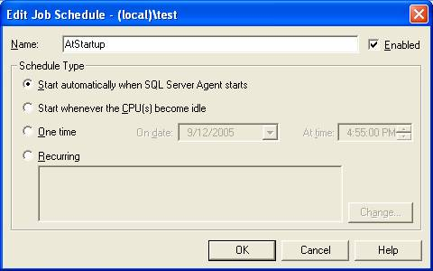
Any job that uses the schedule type of "Start Automatically when SQL Server Agent starts" will be run every time SQL Server Agent Starts. Remember SQL Server Agent can be stopped and restarted multiple times without bringing down SQL Server. So keep in mind that this method is not exactly the same as using the autoexecution option for a stored procedure.

Conclusion
As you can see, there are a couple of different ways to autmatically start a process when SQL Server or SQL Agent starts. Keep in mind that the SQL Agent method is slightly different than using the sp_procoption to automatically start a process. If you have a need to automatically start a process whenever SQL Server or SQL Agent starts, then the two options I discussed should be able to help you out.

There is a checkbox when you create an SSIS catalog which says "Enable automatic execution of Integration Services stored procedure at SQL Server startup". It's a good practice to have this option on. BUT! How do you verify whether this option is ON or OFF after you (or someone else) have created a catalog and how do you enable it if it wasn't enabled at the time of creating the catalog?
Thank you for the suggestions in advance!

To see if the checkbox was checked:
SELECT name, is_auto_executed FROM sys.procedures WHERE name = 'sp_ssis_startup'
If 'is_auto_executed' is 1 then it was checked at installation.
To change the value of 'is_auto_executed' to 1 when it wasn't enabled at installation:
EXEC sp_procoption
@ProcName = 'sp_ssis_startup',
@OptionName = 'startup',
@OptionValue = 1;
This should answer your question.

How To Execute an Integration Services (SSIS) Package from a SQL Server Stored Procedure

By: Ray Barley | Read Comments (15) | Related Tips: More > Integration Services Execute Package Options

Problem
My application has a number of requirements for manipulating data and I would like to create SSIS packages to perform these tasks. However, I am unsure of the best way to execute an SSIS package from my application. Can you provide an example of how to do this from a stored procedure?

Solution
Based on your requirements, your application should call a stored procedure that executes an SSIS package. There are two ways to execute an SSIS package from a stored procedure:
- Use the extended stored procedure xp_cmdshell to execute the DTEXEC command line utility.
- In SSIS 2012 use the built-in stored procedures; e.g. ssisdb.catalog.create_execution, ssisdb.catalog.start_execution, etc.
In this tip I walk through an example of executing an SSIS package using the built-in stored procedures that come with SQL Server 2012. I will review the following steps:
- Create a sample SSIS package.
- Deploy the SSIS project using the default project deployment model in SSIS 2012.
- Create a stored procedure to execute the SSIS package.
- Execute the stored procedure in SQL Server Management Studio (SSMS).
- Create a .NET console application to execute the stored procedure.
- Run the .NET console application and check the results.

Create a Sample SSIS Package
I will use the following SSIS package:
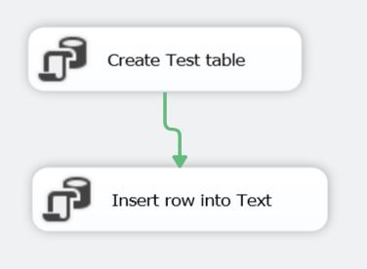
The SSIS package performs the following steps:
- Creates a table named Test if it does not exist.
- Inserts a row into the Test table.
The package is deliberately simple since the focus of this tip is to execute an SSIS package from a stored procedure.

Deploy the SSIS Project
By default SSIS 2012 uses the new project deployment mode where an entire SSIS project is deployed to the SSISDB database. To deploy the project right click the project in the Solution Explorer, select Deploy from the menu, and fill in the dialog as shown below:
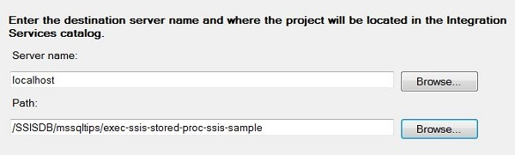
The Path is a combination of the following:
- /SSISDB is the database name; it is fixed and can not be overwritten at this time.
- mssqltips is the folder name; this is user-defined.
- exec-ssis-stored-proc-ssis-sample is the name of my project.
Note that you need to setup the SSISDB catalog; see SSIS Package Deployment Model in SQL Server 2012 for the details.

Create a Stored Procedure
I will use the following stored procedure in my mssqltips database to execute the SSIS package:
create procedure dbo.execute_ssis_package_sample
@output_execution_id bigint output
as
begin
declare @execution_id bigint
exec ssisdb.catalog.create_execution
@folder_name = 'mssqltips'
,@project_name = 'exec-ssis-stored-proc-ssis-sample'
,@package_name = 'Sample.dtsx'
,@execution_id = @execution_id output
exec ssisdb.catalog.start_execution @execution_id
set @output_execution_id = @execution_id
end
The following are the main points about the above stored procedure:
- The stored procedure ssisdb.catalog.create_execution (new in SSIS 2012) is called to create an instance of an SSIS package execution.
- You pass the folder, project and package to the ssisdb.catalog.create_execution stored procedure.
- ssisdb.catalog.create_execution returns an output parameter named @execution_id; you need this value to start executing the SSIS package as well as to check the status of package execution.
- The ssisdb.catalog.start_execution stored procedure (new in SSIS 2012) is called to start the actual execution of the package.
- The SSIS package execution is asynchronous; i.e. when you call the ssisdb.catalog.start_execution stored procedure you are not waiting for the package to complete.

Execute the Stored Procedure
Launch SSMS, open a New Query, and run the following T-SQL script:
declare @output_execution_id bigint
exec dbo.execute_ssis_package_sample @output_execution_id output
print @output_execution_id
You have now executed an SSIS package from a stored procedure!

Create a Console Application
I will use a .NET console application to demonstrate executing an SSIS package from an application. The C# code below is standard ADO.NET which is the part of the .NET Framework that is used to work with relational databases. Essentially the code simply executes the execute_ssis_package_sample stored procedure described in the previous section.
The following is the "Main" section of the code (i.e. this is the code run when the console application is executed):
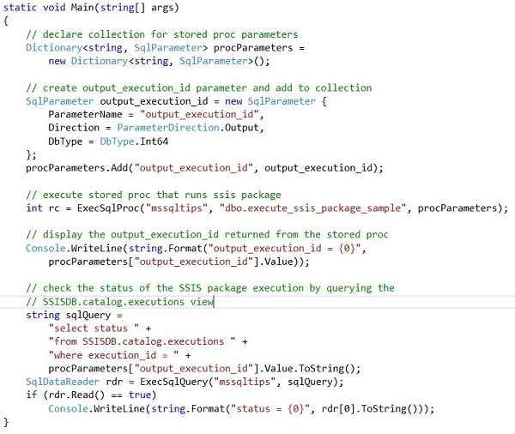
The following is the ExecSqlProc method called from Main; this is the code that calls the stored procedure that executes the SSIS package:
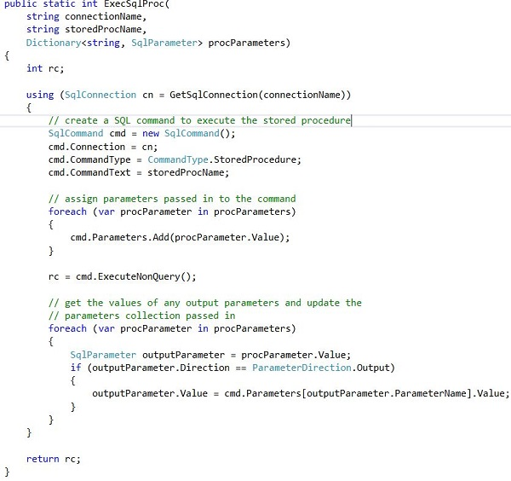
The ExecSqlProc method calls the GetSqlConnection method shown below to open a connection to the mssqltips database:
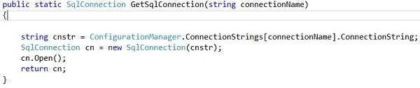
The connectionName parameter passed to the GetSqlConnection method must match a connection string in the app.config as shown below:
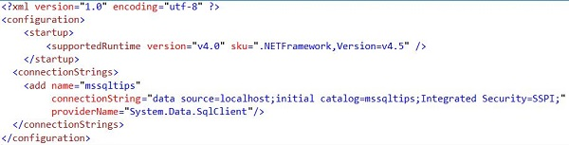

Check the Results
After running the .NET console application or running the execute-ssis-package-sample stored procedure, you can check the results of the SSIS package execution with the following query (where N is the output_execution_id returned as an output parameter by the ssisdb.catalog.create_execution stored procedure):
select status
from SSISDB.catalog.executions
where execution_id = N
A status of 7 means the SSIS package ran successfully. A status of 2 indicates that the SSIS package is still running. There are 9 possible status values; see catalog.executions for the details.
The following method can be used to programmatically check the status (it is called from the Main code above; see the code following the "check the status" comment):
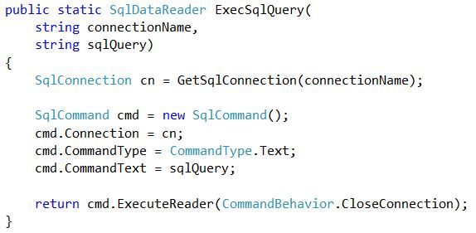

Next Steps
- SSIS 2012 has built-in stored procedures in the SSISDB database allowing you to easily execute an SSIS package from a stored procedure.
- While the above sample code is pretty straight forward, remember that the SSIS package execution happens asynchronously; i.e. your code that calls the stored procedure doesn't wait for the SSIS package to finish. You can query the SSISDB.catalog.executions view to determine the status of the SSIS package execution.
- Download the sample SSIS project and .NET console application here to experiment on your own.
Last Update: 7/2/2013

About the author
Ray Barley is a Principal Architect at RDA Corporation and a MSSQLTips.com BI Expert.

